The after effect system requirement is high . It is not that heavy but you can do basic things here but eventually when you reach the advanced level then it will be heavy . Yes you rsystem resources may get utilised
Teacher specs are I7 core laptop ,gaming laptop , HP Omen, Core I7, 16 gb RAM ,1050 Ti NVIDIA GPU chip
The more high quality resources you have the more smoothly your system will run
If we talk about desktop vs Laptop then desktop is more powerful
How much powerful laptop you will take it iss jusst a Laptop and Desktop is big machine it has a good cooling system
Teachr is suggesting that you do reseeach on your side what caan run on your machine and what not
If you can afford tehn upgrade it if not have a budget then it will be slow but it will still run

What is a New composition?

The people who have studied Premium pro may know that we used to make new sequence similarly there is composition .Who have not studied it, for them it is like a container or a complete animation or just a small sequence inside which you have completed one task (who knows)
We can make multiple composition and can join them
Remmeber that the composition here we make it small for exmple 10 second or 4 second or 1 minute We don't make full composition here because it become very heavy and by the way for video editing we haave Premuim Pro
Many people ask who is better for editing but they are maade for different purposes
For editing we have Premium Pro
For compositing and motion graphic we have after effect
To create a new project folo below
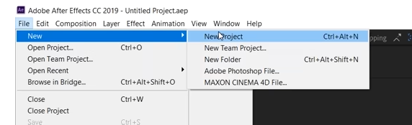
So create a composition first right click on the empty area of project
and then in submenu clcik on new component as shown above and then new window will open as shown below named as Composition Settings
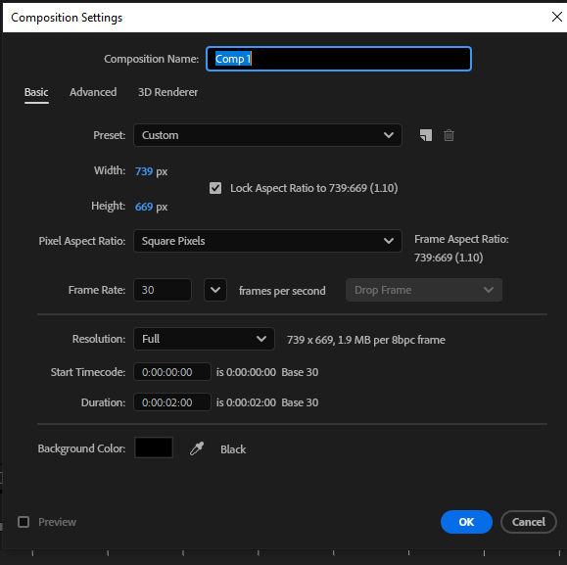
or you can create a new composition by clicking on the marked below aand the saame window above will be opened
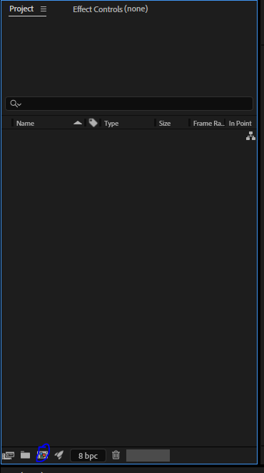
There are pther ways to make composition we can make composition from illustator and Photoshop and import it in After effect We will see it later

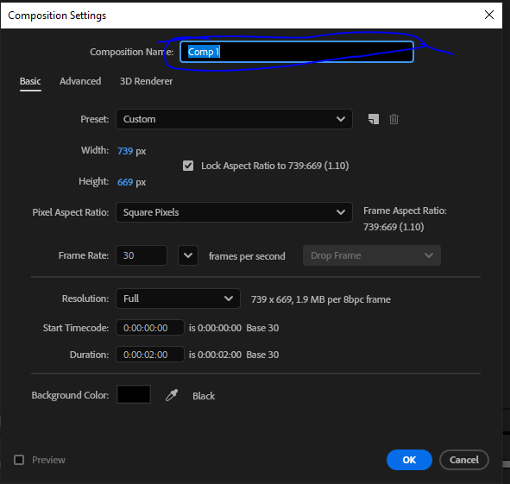
the marked ine is the area you tell teh name of the composition
I name it FirstComposition
and now in preset
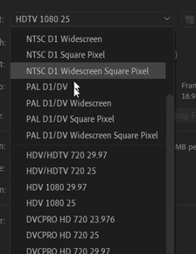
Thee presets are according to the screens where your final ouput will run(maybe these are dimenstion or configuration for that device wwhere the output will run(who knows))
We choose HD 1920 x 1080 25(as HDTV 1080 25 is not available now in newer version)
These are the presets for width , height and frame rate.
You can click on drop down of frame rate to see a drop down and in drop down you can choose frame rate as shown below
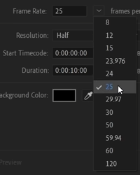
or ou can type your frame rate normally by typing in the frame raate field beside the drop down
Now in resolution type we can choose full, half , third, quarter etc.
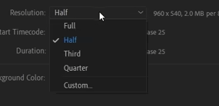
I think it tells us the how much pixel information will be stored in our screen or rectngular group of pixels where the image will be shown
If hallf is choosen then haf of the pixel information will be used in our screen where video is shown
due to which there is loss of quality
If you choose full then the system may get heavy
because in the marked area your video will be shown as marked below area in the
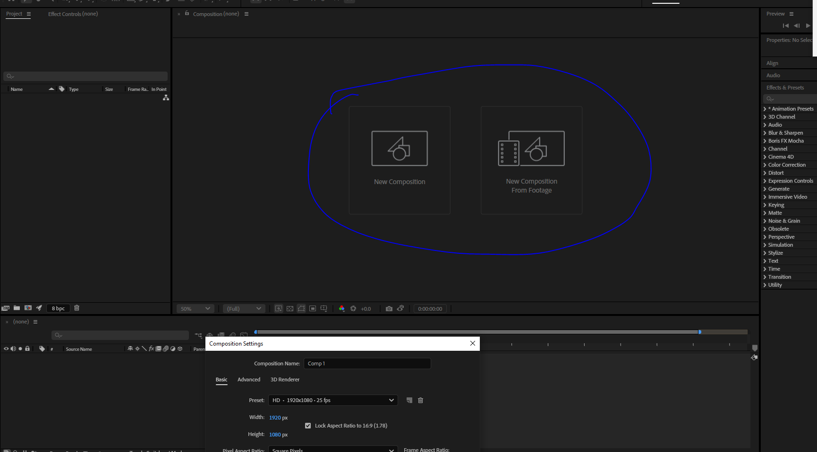
Now in duration we tell how long our composition will be
Its time structure is such that it is divided into foour section by colons
The first colon tell us frame aand then second tell us second and then minutes and then hours as shown below
0:00:10:00
How many frames will mean a second depends on the frame rate we chose
and now in background we tell the background color of the composition which will be seen in the background of the composition formed
By default it color is black
Now click on OK button Now when you click on OK button
Now in our composition window you can see your black background composition as shown below
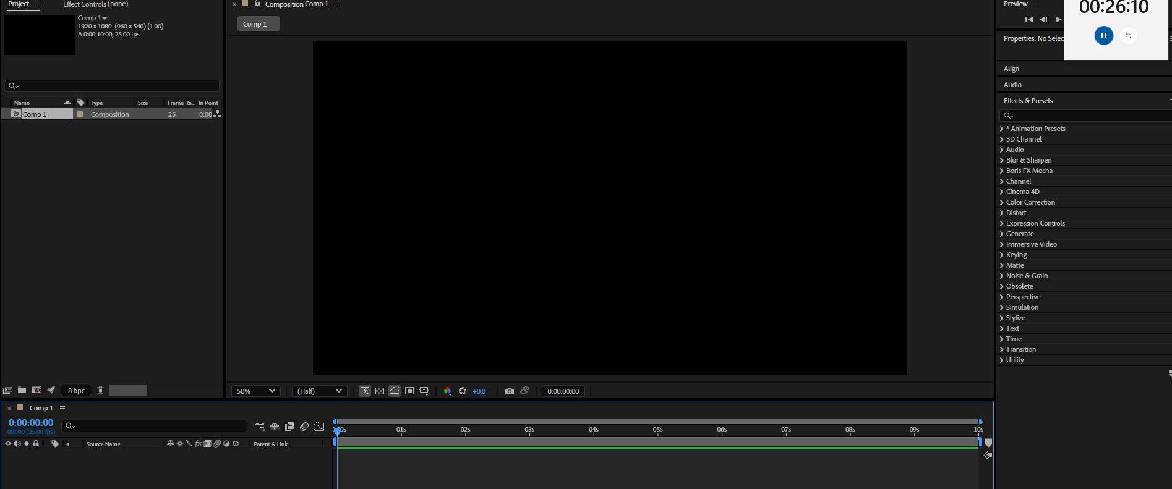
Now you can see the timeline is activated
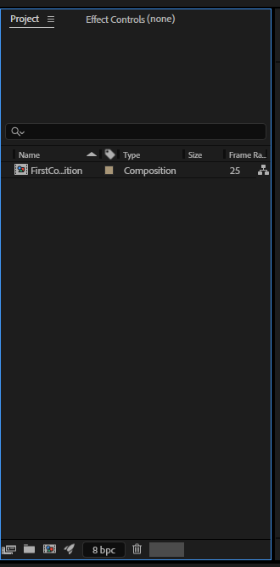
Now in your project panel window you can see the composition we made
Whatever composition you make will be listed here
Whatver whether it is image, video or audio
It is just like a container

Note:-

You can also create a new composition through Composition window but condition is there should be no composition on project panel if there are composition then delete them all
and then in composition window click on marked below and then the rest of the process is same
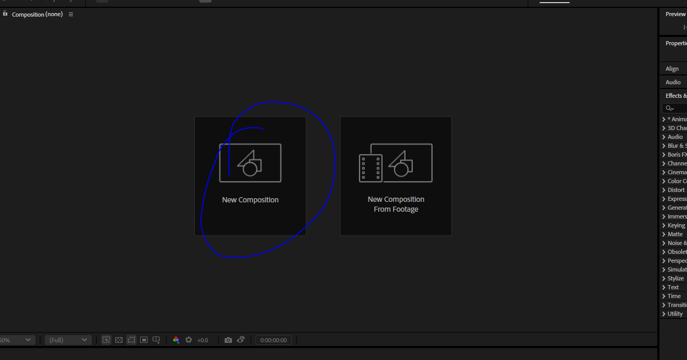
Now if we want to import an image or video hten right click on the project panel

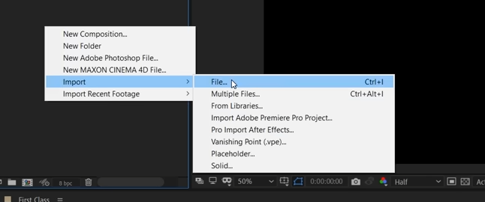
and then go to import and then to File Now browse window will be opened like below select the file you want to

